An Industrial Training Report On

FOOD ORDERING WEBSITE

Held at

**Intershala**

Submitted in partial fulfilment of award of

**BACHELOR OF TECHNOLOGY**

degree in

##### COMPUTER SCIENCE AND ENGINEERING

By

**TANU**

(2200820109014)

Under the guidance of

**Dr. Neelaksh Sheel**

**Mr. Vikas Bhatnagar**



**Department of Computer Science and Engineering Moradabad (U.P) MORADABAD INSTITUE OF TECHNOLOGY**

**Session 2023-24**

# CERTIFICATE

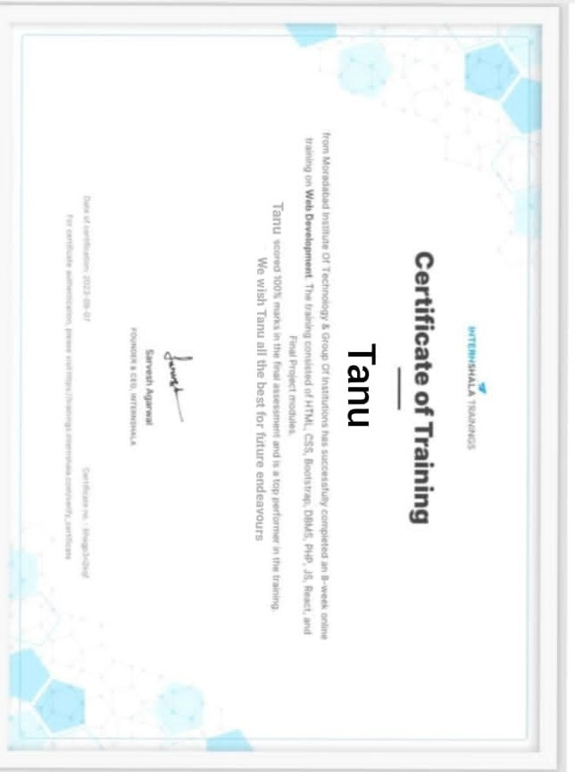

# ABSTRACT

This report presents the experience and skills gained during my 2 months of training cum learning on “Internshala” . My training was understanding about

web development and gaining the basic knowledge about the concepts such as HTML,CSS,JS.

In the beginning, I focused on creating layouts using float, flexbox, and grid in HTML, which allowed me to grasp essential concepts in front-end development. I then delved into CSS, mastering various techniques and creating four different dashboards for the company, each with unique functionalities.

This report discusses the skills gained and experienced gathered during this period and discusses about the Online & Food Ordering developed using HTML,CSS,JS.

# 

# ACKNOWLEDGEMENT

I would like to express my heartfelt gratitude to all those who have contributed to the completion of this report. This endeavour would not have been possible without the support, guidance, and encouragement of several individuals and organizations.

First and foremost, I extend my sincere appreciation to Dr. Neelaksh Sheel(Assistant Professor) and Mr. Vikas Bhatnagar(Assistant Professor) for positive attitude shown to our work.

Furthermore, I want to express my appreciation to my family for their unwavering support and understanding during this project. Your encouragement and belief in my abilities have been a constant source of motivation.

Lastly, The guidance and support received from all the members who contributed and who are contributing to this project, was vital for the success of the project. We are grateful for their constant support and help.

TANU

v

# LIST OF FIGURES

**FIGURE NO FIGURE NAME PAGE**

Figure 1 Complete Visualization model....................................................................................................…13

Figure 2 Food Delivery Market........................................................................................................................14

Figure 3 Home Page………………...................................................................................................................17

Figure 4 Category1………….....................................................................................................……..............18

Figure 5 Category2……………………………………………………………………….18

Figure 6 Checkout ..........…………………….......................................................................................................19

Figure 7 Place Order....................................…….................................................................................................19

vi

**TABLE OF CONTENTS**

**CONTENT PAGE NO.**

ABSTRACT iii

ACKNOWLEDGEMENT iv

LIST OF FIGURES .v

**CHAPTER 1: OBJECTIVE OF TRAINING**

1.1 Details of the Company ...................................................................................................................7

1.2 Objectives behind Internship ..........................................................................................….........…8

1.3 Achievements after Internship ...................……………………………………………………….8-9

**CHAPTER 2: ONLINE FOOD ORDERING**

2.1 Introduction…….. ............................................................…...........................................................10

2.2 Rationale………….........................................................................................................................10-11

2.3 Objectives………….........................................................................................................................11

2.4 Need of Online Order……………………......................................................….............................11

2.5 Functionalities .................……….………………………………………………………………...11-12

2.6 Features……............................................................................................………………..….........12

**CHAPTER 3: METHODOLOGY**

3.1 Complete Visualization of online food ordering system………....................……….................... 13

3.2 Market Potential of Online Food Ordering System……………....................……….................... 14

3.3 Tools and Technique used……………………………...………....................……….................... 15

3.3.1 HTML…………………………………………………………………………………………….15

3.3.2 CSS….…………………………………………………………………………………………….15

3.3.3 JavaScript………………………………………………………………………………………..15-16

3.3.4 Bootstrap…………………………………………………………………………………………..16

3.3.5Visual Studio Code…………………………………………………...…………………………….16

**CHAPTER 4: SNAPSHOTS OF THE PROJECT…………….**……………………………….……..17

**CHAPTER 5: CONCLUSION** …………………….…………………………………………….….....21

**CHAPTER 6: REFERENCES …...**…………………………………………………………...….…….23

**CHAPTER 1**

**OBJECTIVE OF TRAINING**

I have completed my training from Internshala. I have done my training on the topic of Web Development, while also building the projects like Food Ordering website, E-Commerce website etc.

## DETAILS OF COMPANY

Internshala is an online recruitment and training platform. On recruitment portal of Internshala, the internship seekers and job-seeking freshers from all over India, across different education streams, can search and apply to various internships and fresher jobs of their choice and organisations. Additionally, startups, corporates, SMEs, NGOs, education institutes, and big brands, can post their intern and entry-level job requirements to hire university students and fresh graduates all over India. On Internshala Trainings, the e- learning arm of Internshala, the online learners including students and professionals can avail online trainings in the latest in-demand industry skills to build their career, upskill themselves, and become industry-ready.

Internshala aims to address Students with all careers related queries and giving practical exposure to trending technologies. It is an online learning platform that provides individuals with the skills and knowledge they need to succeed in tech. It offers a wide range of courses on topics such as machine learning, ethical hacking, android -app development , automobile , iot , python programming , java programming and data science. It is open to everyone, regardless of their age, experience, or background. Learners can create a free account and start learning at their own pace with lifetime access. Courses are typically self-paced and include video lectures with different and well-defined modules. Upon completion of a course, learners will earn a digital credential that they can share with potential employers. On completion of course and after submission of project the user gets a training certificate recognised by every institution. Internshala is a great way to learn in-demand tech skills and prepare for a career in fields.

## OBJECTIVES BEHIND TRAINING

I had completed my training from Internshala where I had completed my training under Web Development domain. I had learnt about basics of different machine learning algorithms and their implementation by doing model evaluation using Python. I had gone through various learning approach that is “Supervised Learning”, “Unsupervised Learning”, “Reinforcement Learning”, “Deep Learning” etc. I have gained knowledge of various algorithms in these learning approaches. I also got knowledge about data cleaning, pre- processing, feature engineering and many more.

I had opted for this internship to learn more about Machine Learning as it is an evolving field with new techniques and algorithms emerging regularly and it offered me generate the required skills so that I am having the required potential to be industry ready.

## ACHIEVEMENTS AFTER TRAINING

During the intern-ship, I had the opportunity to work on a web development project that utilized HTML, CSS, JavaScript and to create a dynamic and responsive website. This project was not only a valuable learning experience but also resulted in significant achievements and contributions.

1. **Mastery of Front-End Technologies-**The project allowed me to gain proficiency in the core technologies of front-end web development, namely HTML, CSS, JavaScript and reactjs . I became well-versed in creating visually appealing and interactive web interfaces.

**2. Problem-Solving Skills-**Throughout the project, I encountered various challenges and had to employ problem-solving skills to find solutions. This honed my ability to troubleshoot and debug issues in real-world web development scenarios.

1. **User-Centric Design-**The focus on responsive design and interactive elements highlighted the importance of creating user-friendly web experiences. This experience will be invaluable in future web development endeavors.#

The achievements gained from this project set a solid foundation for future endeavors in web development. The skills acquired in HTML, CSS, and JavaScript, along with the problem-solving and design abilities, can be applied to more complex projects and contribute to a successful career in web development or related fields.

# CHAPTER 2

**ONINE FOOD ORDERING**

## **2.1 INTRODUCTION**

**Online food ordering** is the process of ordering food from a website. The product can either be food that has been specially prepared for direct consumption (such as vegetables straight from a farm or garden, frozen meats, etc.) or food that has not been (such as direct from a certified home- kitchen, restaurant). The effort to create an online food ordering system aims to replace the manual method of taking orders with a digital one. The ability to rapidly and correctly create order summary reports whenever necessary is a key factor in the development of this project.

* User Friendly: Online Food Ordering System is a very user-friendly project because the Food Ordering Record and searching from categories is very simple, fast and data is secured. The user interface of the project is very simple.
* Order reports of the system can be easily generated. User can generate the report of any particular date and period. In this way they can get delivery status of customers and get information about what is being ordered.
* Very less paper work : Online Food Ordering System requires less paper work. In this project all record is fetched directly into the computer and reports can be generated through just a click. In this way it saves time. As data is directly entered into computer so there is no need to do any paper work .

## **2.2 Rationale**

There are several good reasons to create an online food ordering application. There is a lot of demand, which is why so many restaurants are utilizing online ordering. Customers enjoy how convenient it is to

purchase food online and have it delivered to their place of residence or workplace. By providing the services, you may maintain your competitiveness in the restaurant business.

## **2.3 Objectives**

The management of the information regarding item category, food, delivery address, order, and shopping cart is the system's primary goal. It oversees the management of all customer, shopping cart, and item category information. Since the project was entirely developed on the administrative end, only the administrator is assured access. The goal is to develop an application program to simplify managing the food consumer item category. It keeps note of every delivery address requested.

## **2.4 Needs of Online Food Order**

Helping customers in placing meal orders whenever they want. Customers will be able to order their preferred foods at any time, but as we've already mentioned, this is only a limited option. As a result, restaurants need to have a specific system in place that will allow them to serve a large number of customers while streamlining operations. One of the best platforms is ordering, which offers all of these services in addition to a host of cutting-edge features that have helped countless small and large enterprises establish themselves as market leaders.

## **2.5 Functionalities**

* + - Provides search options based on a variety of criteria. like Food Item, Customer, Order, and Order Confirmation.
    - Online food ordering systems also manage payment information for order details, order confirmation details, and food items online.
    - It keeps track of all the data regarding Categories, Payments, Orders, etc.

## **2.6 Features**

## 

* + - Based on products and components.
    - Easily creating and altering issues.
    - Issue List can be queried in any detail.
    - Reporting & Charting in a more thorough manner.
    - User accounts are used to manage access and uphold security.
    - Straightforward status & resolutions.
    - Priorities and severity levels at various levels as well as targets and milestones for the programmers to follow.
    - Attachments & Additional Comments for more information.
    - A solid database back end.
    - Various levels of reports are provided with many filtering options.
    - It has more storage space.
    - Accuracy in the work.
    - Information retrieval is simple and quick. nicely crafted reports.
    - Reduce the workload of the person using the current manual system.
    - Individual access to any information.

# 

# CHAPTER 3

**METHODOLOGY**

## **Complete Visualization of Online Food Ordering System**

An easy-to-use table management system will also be included in a good restaurant reservation setup. This enables restaurants to see their restaurant hour by hour and receive reservations through a variety of ways.

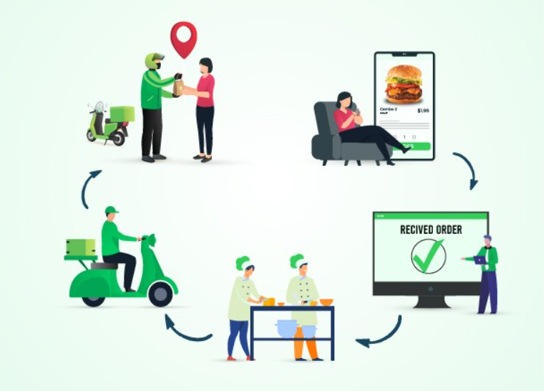

Fig3.1.1:Complete Visualization Model

* 1. **Market Potential Of Online Food Ordering System**

The global online food delivery market was worth used 189.70 billion in 2021 and expected to grow at compound annual growth rate (CAGR) of 10.8% between 2022 and 2028. The market is primarily driven by the growing number of smartphone and internet users,as well as the global trend toward food delivery mobile applications.

According to GSMA ,there were 52 billion smartphone connection in 2019,and by the end 2020.It is expected that half of the world population will have access to mobile internet services.As a result the growing number of smartphone and internet users increase demand for online food delivery plateforms which contributes to market growth.

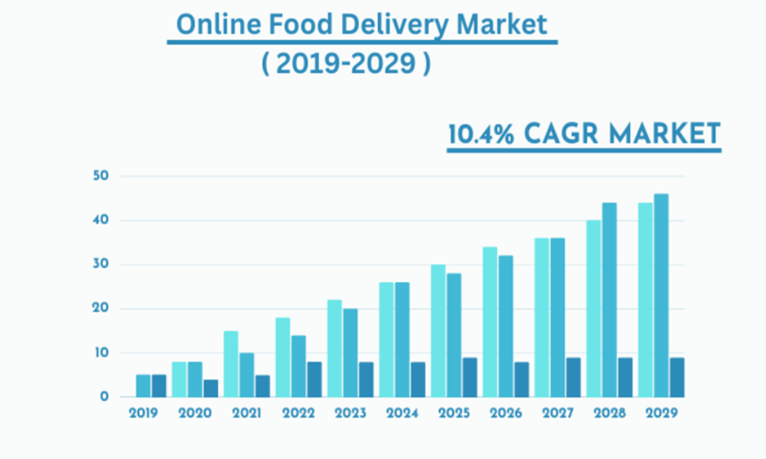

Figure 3.2.1:Food Delivery Market

## **Tools and Technique**

## HTML

## CSS

## Javascript

## Bootstarp

## Visual Studio Code

## **3.3.1 HTML**

## HTML stands for HyperText Markup Language. It is used to design web pages using a markup language. HTML is a combination of Hypertext and Markup language. Hypertext defines the link between web pages. A markup language is used to define the text document within the tag which defines the structure of web pages. This language is used to annotate (make notes for the computer) text so that a machine can understand it and manipulate text accordingly. Most markup languages (e.g. HTML) are human-readable.

## **3.3.2 CSS**

Cascading style sheet is a language for creating style sheets that describe how a document

product in a markup language like HTML will look. The world wide web foundational

technologies,along with HTML and javascript, include CSS.CSS in seprate layout,color,

and font may all be separated from content and presentation using CSS.

## **3.3.3 Java Script**

## JavaScript often abbreviated as JS, is an interpreted, high-level programming language. Additionally, it is a dynamic, weakly typed, prototype-based, and multi-paradigm language. One of the three fundamental technologies of the World Wide Web, together with HTML and CSS, is JavaScript.

## **Bootstrap**

## Bootstrap is a free, open source [front-end](https://www.techtarget.com/whatis/definition/front-end) development framework for the creation of websites and web apps. Designed to enable responsive development of mobile-first websites, Bootstrap provides a collection of syntax for template designs.

## **3.3.5 Visual Studio Code**

## Visual Studio Code is a lightweight but powerful source code editor which runs on your desktop and is available for Windows, macOS and Linux. It comes with built-in support for JavaScript, TypeScript and Node.js and has a rich ecosystem of extensions for other languages and runtimes (such as C++, C#, Java, Python, PHP, Go, .NET).

# CHAPTER 4

# RESULT

## **WEB APP WORKING IMAGES**

# 4.1.1 Home page

# C:\Users\Om\Pictures\Screenshots\Screenshot (23).png

# Fig4.1.1:Home Page

4.1.2 Categories

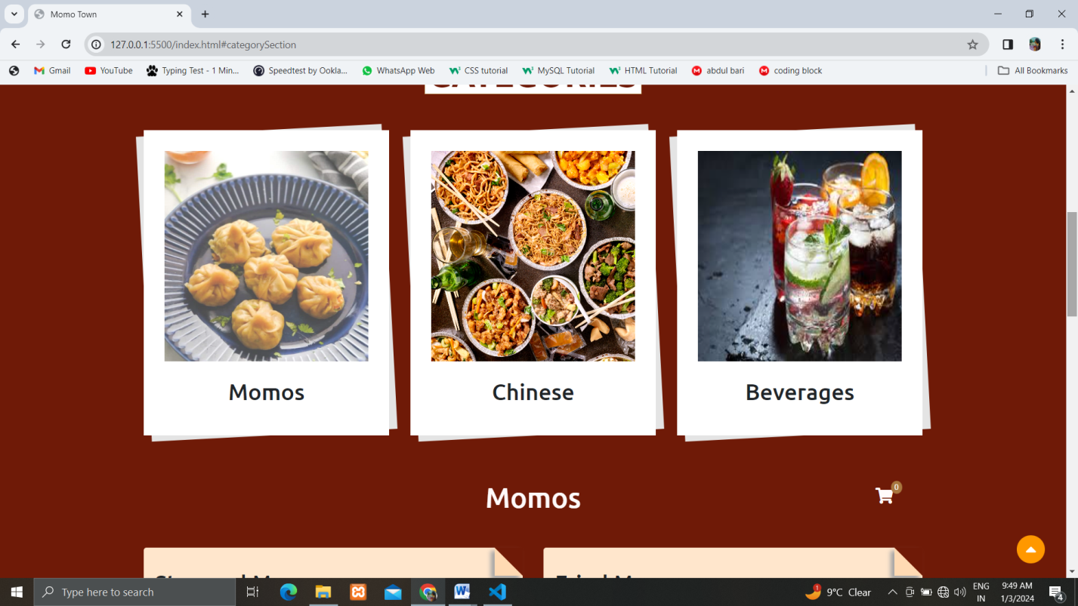

Fig4.1.2:Category1

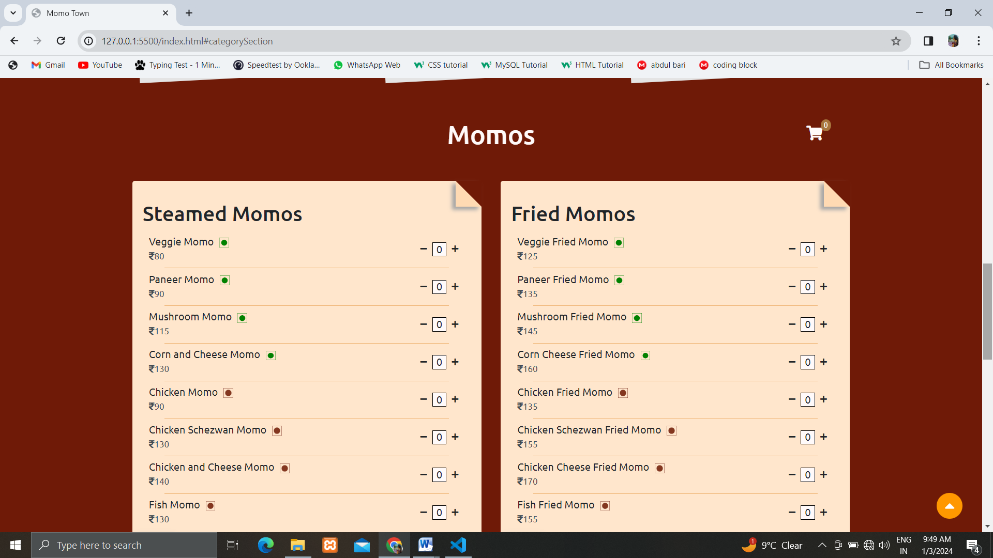

Fig4.1.2:Category2

5.1.3 Checkout

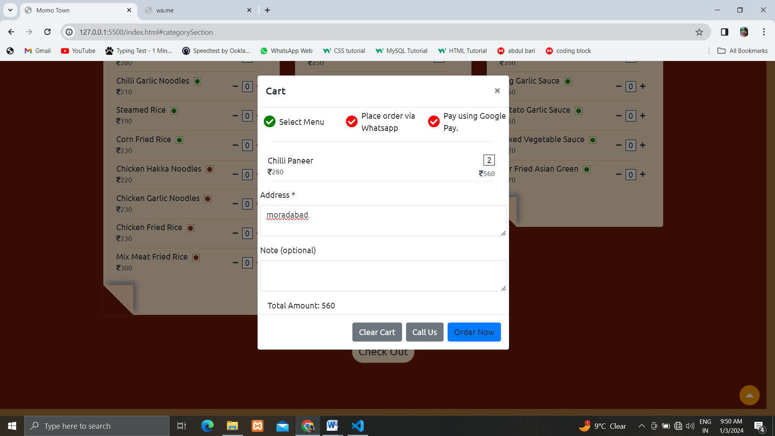

Fig4.1.3:Checkout

5.1.4 Place Order

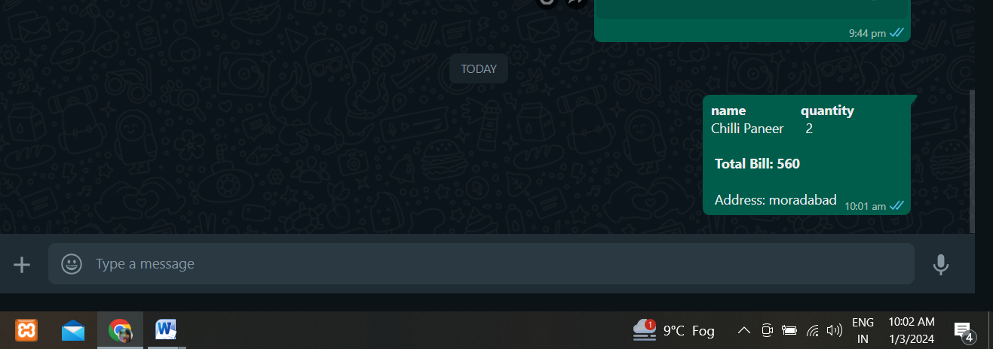

Fig4.1.4:Place Order

* 1. **Result & Discussion**

The final output is a complete web based Online Food Ordering system, which can be used in any kind of restaurant. This Restaurant Management System can help to manage the Restaurant more effectively, efficiently and smoothly. This is more secured and there will be speedy and well ordered authentication procedure for the maintenance of records. At present time, in this technology based world, people likes and wants everything to be smooth and efficient through the use of data and information. In this perspective, our Restaurant Management System can be an ideal platform for the users. Its user friendly interface can help the customers to find his/her desired menu item and place order with a few click. Customers can easily place an online order by browsing the menu options, pick what they want sitting at home. And can also receive their food in a short period of time.

## Advantages

* + - It is quick, simple, and pleasant.
    - Managing an online menu is easier.
    - Access is only a click away.
    - Less work for you.

# CHAPTER 5

# CONCLUSION & FUTUREWORK

**5.1 Conclusion**

Online Food Ordering is a web-based technology that aids the restaurant industry in carrying out tasks effectively and efficiently. It aids in managing cash flow for managers. Managers can view analytics data to assess company growth. The manager can control orders and employee schedules by using this system. The full complement is a restaurant management system. It provides access to the Online Order platform, third-party connectors software, and comprehensive CRM solution, which together cover a sizable portion of your restaurant's requirements. They are not the outdated hardware and software sets for restaurants that were previously offered. They are the hottest things around, smooth, manageable, inexpensive, and quick.

In the "Online Food Ordering Project," we made every effort to meet all the demands of the restaurant. Because it is straightforward and adaptable, the project is successful. The biggest benefit of my project is that it draws plenty of users because of its simplicity. A novice user may operate it with ease. Any type of restaurant can utilize our software. By automating meal ordering, billing, and inventory control, the restaurant management system assists the restaurant manager in managing the restaurant more successfully and efficiently.

## **5.2 Future Work**

Each project should pay close attention to future development because it contains the system's most recent features. It lessens software issues and defects. It develops a close relationship with customers based on their comments or preferences. Developer will incorporate certain dynamic elements that are briefly described below into my online food ordereing.

* + - Modern architecture with smooth transitions.
    - System for email and mobile confirmation.
    - Selling Point

# 

# 

# CHAPTER 6

### REFERENCES

[1] <https://www.javatpoint.com/javascript-tutorial>

[2] [https://www.w3schools.com](https://www.w3schools.com/python/)/HTML&CSS

[3] https://getbootstrap.com/docs/5.3/components/navbar/

[4] [www.codecademy.com](http://www.codecademy.com)

[5][https://www.geeksforgeeks.org/design-a-webpage-for-online-food-delivery-system-using-html- and-css/](https://www.geeksforgeeks.org/design-a-webpage-for-online-food-delivery-system-using-html-%20and-css/)

[6] https://codevoweb.com/lc24-responsive-food-delivery-website-with-html-css-and-javascript/